

A Center of Grace in Whittier, California

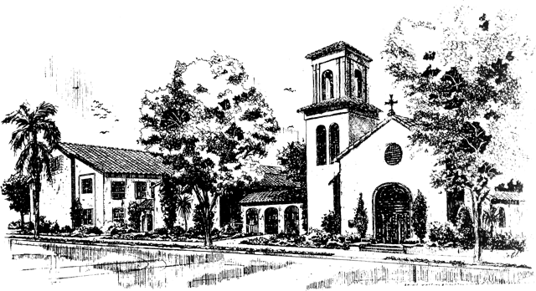

The Second Sunday of Easter

April 11, 2021

10:00 a.m.

Jesus Christ is the reason we are together. The goals of St. Matthias Church

and all of its related ministries are to build our relationship with God through

Jesus Christ and to build community with the people God has sent to us.

**Prelude** Fantasie in C – *Poco lento* César Frank

Don Brown – guest organist

*Please join in singing the hymns and service music wherever you may be…*

**Processional Hymn** Good Christians all, rejoice and sing… *Gelobt sei Gott*



Hymnal 1982: #205: Words: Cyril A. Alington (1872-1955), alt. St. 5, Norman Mealy (1923-1987) Music: *Gelobt sei Gott*, Melchior Vulpius (1560?-1616) Copyright: Words: Copyright © 1958, renewal 1986, by Hope Publishing company, Carol Stream, IL 60188. All Rights Reserved. Used by Permission. St.5, Copyright © 1971 by Walton Music Corporation. Used by permission.

**THE WORD OF GOD**

*Celebrant* Alleluia, Christ is risen.

People **The Lord is risen indeed. Alleluia.**

*Celebrant & People* **Almighty God, to you all hearts are open, all desires known, and from you no secrets are hid: Cleanse the thoughts of our hearts by the inspiration of your Holy Spirit, that we may perfectly love you, and worthily magnify your holy Name; through Christ our Lord. Amen.**

**The Collect of the Day**

*Celebrant* The Lord be with you.

*People* **And also with you.**

*Celebrant* Let us pray.

Almighty and everlasting God, who in the Paschal mystery established the new covenant of reconciliation: Grant that all who have been reborn into the fellowship of Christ's Body may show forth in their lives what they profess by their faith; through Jesus Christ our Lord, who lives and reigns with you and the Holy Spirit, one God, for ever and ever. ***Amen.***

**The First Reading****Acts 4:32-35**

Now the whole group of those who believed were of one heart and soul, and no one claimed private ownership of any possessions, but everything they owned was held in common. With great power the apostles gave their testimony to the resurrection of the Lord Jesus, and great grace was upon them all. There was not a needy person among them, for as many as owned lands or houses sold them and brought the proceeds of what was sold. They laid it at the apostles' feet, and it was distributed to each as any had need.

*Reader* The Word of the Lord.

*People* **Thanks be to God.**

**Psalm 133** Plainsong Tone 1.2

*The hash mark (/) in the text corresponds to the hash mark in the music.*

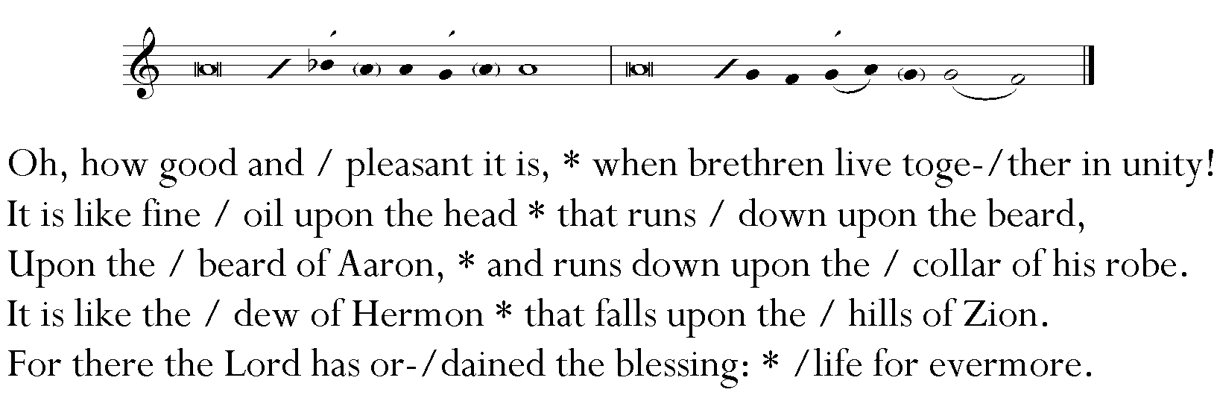

**The Second Reading****1 John 1:1-2:2**

We declare to you what was from the beginning, what we have heard, what we have seen with our eyes, what we have looked at and touched with our hands, concerning the word of life––his life was revealed, and we have seen it and testify to it, and declare to you the eternal life that was with the Father and was revealed to us––we declare to you what we have seen and heard so that you also may have fellowship with us; and truly our fellowship is with the Father and with his Son Jesus Christ. We are writing these things so that our joy may be complete. This is the message we have heard from him and proclaim to you, that God is light and in him there is no darkness at all. If we say that we have fellowship with him while we are walking in darkness, we lie and do not do what is true; but if we walk in the light as he himself is in the light, we have fellowship with one another, and the blood of Jesus his Son cleanses us from all sin. If we say that we have no sin, we deceive ourselves, and the truth is not in us. If we confess our sins, he who is faithful and just will forgive us our sins and cleanse us from all unrighteousness. If we say that we have not sinned, we make him a liar, and his word is not in us. My little children, I am writing these things to you so that you may not sin. But if anyone does sin, we have an advocate with the Father, Jesus Christ the righteous; and he is the atoning sacrifice for our sins, and not for ours only but also for the sins of the whole world.

*Reader* The Word of the Lord.

People **Thanks be to God.**

**Sequence Hymn** We walk by faith, and not by sight… *St. Botolph*

*Stanzas 1& 2 before the Gospel; Stzs. 3 & 4 following the Gospel*

**

Hymnal 1982: #209: Words: Henry Alford (1810-1871), alt. Music: *St. Botolph*, Gordon Slater (1896-1979) Copyright: Music: By permission of Oxford University Press.

**The Gospel John 20:19-31**

*Celebrant* The Holy Gospel of our Lord Jesus Christ according to John.

*People*  **Glory to you, Lord Christ.**

When it was evening on that day, the first day of the week, and the doors of the house where the disciples had met were locked for fear of the Jews, Jesus came and stood among them and said, "Peace be with you." After he said this, he showed them his hands and his side. Then the disciples rejoiced when they saw the Lord. Jesus said to them again, "Peace be with you. As the Father has sent me, so I send you." When he had said this, he breathed on them and said to them, "Receive the Holy Spirit. If you forgive the sins of any, they are forgiven them; if you retain the sins of any, they are retained."

But Thomas (who was called the Twin), one of the twelve, was not with them when Jesus came. So the other disciples told him, "We have seen the Lord." But he said to them, "Unless I see the mark of the nails in his hands, and put my finger in the mark of the nails and my hand in his side, I will not believe."

A week later his disciples were again in the house, and Thomas was with them. Although the doors were shut, Jesus came and stood among them and said, "Peace be with you." Then he said to Thomas, "Put your finger here and see my hands. Reach out your hand and put it in my side. Do not doubt but believe." Thomas answered him, "My Lord and my God!" Jesus said to him, "Have you believed because you have seen me? Blessed are those who have not seen and yet have come to believe."

Now Jesus did many other signs in the presence of his disciples, which are not written in this book. But these are written so that you may come to believe that Jesus is the Messiah, the Son of God, and that through believing you may have life in his name.

*Celebrant* The Gospel of the Lord.

*People*  **Praise to you, Lord Christ.**

**The Sermon** The Rev. Carole Horton-Howe

**The Nicene Creed**

**We believe in one God, the Father, the Almighty,**

**Maker of Heaven and Earth, of all that is, seen and unseen.**

**We believe in one Lord, Jesus Christ, the only Son of God,**

**Eternally begotten of the Father, God from God, Light from Light,**

**True God from true God, begotten, not made, of one Being with the Father.**   
**Through him all things were made.**

**For us and for our salvation he came down from Heaven:**

**By the power of the Holy Spirit he became incarnate from the Virgin Mary,**

**And was made man.**

**For our sake he was crucified under Pontius Pilate;**

**He suffered death and was buried.**

**On the third day he rose again in accordance with the Scriptures;**

**He ascended into Heaven and is seated at the right hand of the Father.**

**He will come again in glory to judge the living and the dead,**

**And his kingdom will have no end.**

**We believe in the Holy Spirit, the Lord, the giver of life,**

**Who proceeds from the Father and the Son.**

**With the Father and the Son he is worshiped and glorified.**

**He has spoken through the Prophets.**

**We believe in one holy catholic and apostolic Church.**

**We acknowledge one baptism for the forgiveness of sins.**

**We look for the resurrection of the dead,**

**And the life of the world to come. Amen.**

**The Prayers of the People Form III**

*The Reader and People pray responsively.*

Father, we pray for your holy Catholic Church:

**That we all may be one.**

Grant that every member of the Church may truly and humbly serve you:

**That your Name may be glorified by all people.**

We pray for all bishops, priests, and deacons:

**That they may be faithful ministers of your Word and Sacraments.**

We pray for all who govern and hold authority in the nations of the world:

**That there may be justice and peace on the Earth.**

Give us grace to do your will in all that we undertake:

**That our works may find favor in your sight.**

Have compassion on those who suffer from any grief or trouble:

**That they may be delivered from their distress.**

Give to the departed eternal rest:

**Let light perpetual shine upon them.**

We praise you for your saints who have entered into joy:

**May we also come to share in your heavenly kingdom.**

Let us pray for our own needs and those of others.

*Silence. The People may add their own petitions. The Celebrant adds a concluding Collect:*

*Celebrant* Almighty God, kindle, we pray, in every heart the true love of peace, and guide with your wisdom those who take counsel for the nations of the Earth, that in tranquility your dominion may increase until the Earth is filled with the knowledge of your love; through Jesus Christ our Lord, who lives and reigns with you, in the unity of the Holy Spirit, one God, now and forever.

*Celebrant & People* **Amen.**

*Celebrant* We pray to you for the forgiveness of sins.

*Silence.*

*Celebrant & People* **Have mercy upon us, most merciful Father; in your compassion forgive us our sins, known and unknown, things done and left undone; and so uphold us by your Spirit that we may live and serve you in newness of life, to the honor and glory of your Name; through Jesus Christ our Lord. Amen.**

*Celebrant* Almighty God have mercy on you, forgive you all your sins through our Lord Jesus Christ, strengthen you in all goodness, and by the power of the Holy Spirit keep you in eternal life.

*Celebrant & People* **Amen.**

**The Peace**

**Announcements**

**THE HOLY COMMUNION**

**Offertory** I know that my redeemer liveth… from *Messiah* G.F. Handel

I know that my redeemer liveth, and that he shall stand at the latter day upon the earth…

and thought worms destroy this body, yet in my flesh shall I see God…

For now is Christ risen from the dead, the first fruits of them that sleep…

Charissa Harjo - soprano

**Presentation** – Doxology *Old 100th*

*Please join in singing wherever you are*

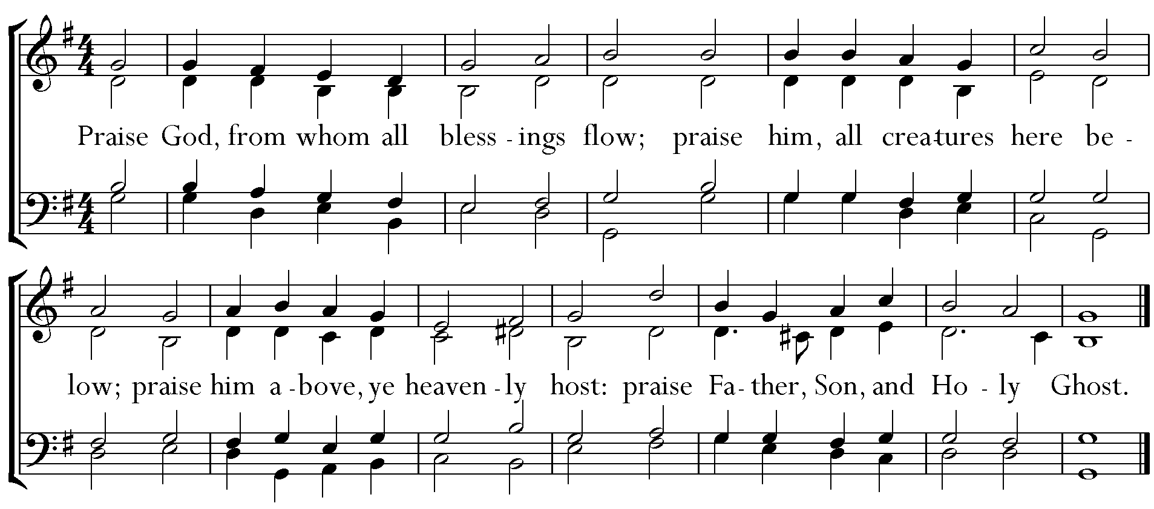

**The Great Thanksgiving Eucharistic Prayer “A”**

*Celebrant* The Lord be with you.

*People* **And also with you.**

*Celebrant* Lift up your hearts.

*People* **We lift them to the Lord.**

*Celebrant* Let us give thanks to the Lord our God.

*People* **It is right to give God thanks and praise.**

*Celebrant* It is right, and a good and joyful thing, always & everywhere to give thanks to you, Father Almighty, creator of Heaven and Earth.

*Here a proper preface is said.*

*Celebrant* Therefore we praise you, joining our voices with angels and archangels and with all the company of Heaven, who forever sing this hymn to proclaim the glory of your Name:

**Sanctus**



Hymnal 1982: #S-128: Music: William Mathias (1934-1992) Copyright: Copyright © 1976 Oxford University Press.

*Celebrant* Holy and gracious Father: In your infinite love you made us for yourself; and, when we had fallen into sin and become subject to evil and death, you, in your mercy, sent Jesus Christ, your only and eternal Son, to share our human nature, to live and die as one of us, to reconcile us to you, the God and Father of all.

He stretched out his arms upon the cross, and offered himself in obedience to your will, a perfect sacrifice for the whole world.

On the night he was handed over to suffering and death, our Lord Jesus Christ took bread; and when he had given thanks to you, he broke it, and gave it to his disciples, and said, “Take, eat: This is my Body, which is given for you. Do this for the remembrance of me.”

After supper he took the cup of wine; and when he had given thanks, he gave it to them, and said, “Drink this, all of you: This is my Blood of the new Covenant, which is shed for you and for many for the forgiveness of sins. Whenever you drink it, do this for the remembrance of me.”

Therefore we proclaim the mystery of faith.

*Celebrant & People* **Christ has died. Christ is risen. Christ will come again.**

*Celebrant* We celebrate the memorial of our redemption, O Father, in this sacrifice of praise and thanksgiving. Recalling his death, resurrection, and ascension, we offer you these gifts. Sanctify them by your Holy Spirit to be for your people the Body and Blood of your Son, the holy food and drink of new and unending life in him. Sanctify us also that we may faithfully receive this holy Sacrament, and serve you in unity, constancy, and peace; and at the last day bring us with all your saints into the joy of your eternal kingdom. All this we ask through your Son Jesus Christ.

By him, and with him, and in him, in the unity of the Holy Spirit all honor and glory is yours, Almighty Father, now and forever*.*

*Celebrant & People* **Amen.**

*Presider* And now, as our Savior Christ has taught us, we are bold to say

*People & Presider* **Our Father, who art in heaven, hallowed be thy Name, thy kingdom come, thy will be done, on earth as it is in heaven. Give us this day our daily bread. And forgive us our trespasses, as we forgive those who trespass against us. And lead us not into temptation but deliver us from evil. For thine is the kingdom, and the power, and the glory, forever and ever. Amen.**

**The Breaking of the Bread**

*The Celebrant breaks the consecrated bread; a period of silence is kept.*

*Presider* Alleluia. Christ our Passover is sacrificed for us;

*People* **Therefore let us keep the feast. Alleluia.**

*Presider* The Gifts of God for the People of God. The Holy Spirit makes the body and blood of our Savior Jesus Christ available in this moment to each of us within our souls as God recognizes our need during this time away from our home.

**Communion Hymn** O sons and daughters… *O filii et filiae*

**

Hymnal 1982: #203: Words: Jean Tisserand (15th cent.); tr. John Mason Neale (1818-1866) Music: *O filii et filiae*, melody from *Airs sur les hymnes sacrez, odes et noëls*, 1623; harm. *Hymnal 1982* Copyright: Music: Harmonization © by The Church Pension Fund.

*Celebrant* Let us pray.

**Lord, make us instruments of your peace.   
Where there is hatred, let us sow love;   
where there is injury, pardon;**

**where there is discord, union;**

**where there is doubt, faith;**

**where there is despair, hope;**

**where there is darkness, light;**

**where there is sadness, joy. Grant that we may not so much seek to be consoled as to console;**

**to be understood as to understand;**

**to be loved as to love.**

**For it is in giving that we receive;**

**it is in pardoning that we are pardoned;**

**and it is in dying that we are born to eternal life. Amen.**

**Recessional Hymn** I want to walk as a child of the light… *Houston*





Hymnal 1982: #490: Words: Kathleen Thomerson (b. 1934) Music: Houston, Kathleen Thomerson (b. 1934) Copyright: Words: Copyright © 1970, 1975, Celebration, Aliquippa, PA 15001. All Rights Reserved. Used by permission.

**The Blessing**

**The Dismissal**

*Celebrant* Go in peace to love and serve the Lord, doing the loving thing.

*People* **Thanks be to God.**

*The Bible texts of the Old Testament, Epistle and Gospel lessons are from the New Revised Standard Version Bible, copyright 1989 by the Division of Christian Education of the National Council of the Church of Christ in the USA, and used by permission. The Collects, Psalms and Canticles are from the Book of Common Prayer, 1979.*

Saint Matthias Episcopal Church  
7056 Washington Avenue, Whittier, CA  90602

Tel: (562) 698-9741 Fax: (562) 698-4347

Website: [www.stmatthiaswhittier.org](http://www.stmatthiaswhittier.com/) Email: office@stmatthiaswhittier.org