****

A Center of Grace in Whittier, California

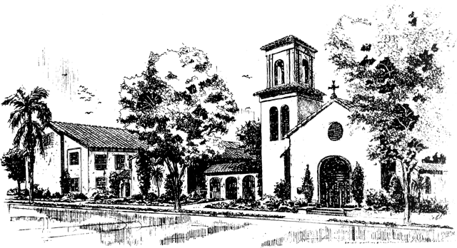

z

Easter Sunday

Feast of the Resurrection

April 4, 2021

10:00 a.m.

Jesus Christ is the reason we are together. The goals of St. Matthias Church

and all of its related ministries are to build our relationship with God through

Jesus Christ and to build community with the people God has sent to us.

**Prelude**

Chorale Prelude on *Easter Hymn* Robert J. Powell

Chorale Prelude on *Heut’ triumphiret Gottes Sohn* (Today, God’s son triumphs) J.S. Bach

*Please sing the hymns and service music from wherever you may be…*

**Processional Hymn** Jesus Christ is risen today… *Easter Hymn*

C:\Users\Kevin\Documents\Scores\Jesus Christ is risen today_Easter Hymn_no descant\Jesus Christ is risen today_Easter Hymn_no descant (2).tif

Hymnal 1982: #207: Words: Latin, 14th cent.; tr. *Lyra Davidica*, 1708, alt. St. 4, Charles Wesley (1707-1788)Music: *Easter Hymn*, from *Lyra Davidica*, 1708; adapt. *The Compleat Psalmodist*, 1749, alt., All Rights Reserved. Used by Permission.

**THE WORD OF GOD**

*Celebrant* Alleluia, Christ is risen.

*People* **The Lord is risen indeed. Alleluia.**

*Celebrant & People* **Almighty God, to you all hearts are open, all desires known, and from you no secrets are hid: Cleanse the thoughts of our hearts by the inspiration of your Holy Spirit, that we may perfectly love you, and worthily magnify your holy Name; through Christ our Lord. Amen.**

**The Collect of the Day**

*Celebrant* The Lord be with you.

*People* ***And also with you.***

*Celebrant* Let us pray.

Almighty God, who through your only-begotten Son Jesus Christ overcame death and opened to us the gate of everlasting life: Grant that we, who celebrate with joy the day of the Lord's resurrection, may be raised from the death of sin by your life-giving Spirit; through Jesus Christ our Lord, who lives and reigns with you and the Holy Spirit, one God, now and forever. ***Amen.***

**The First Reading****Acts 10:34-43**

Peter began to speak to Cornelius and the other Gentiles: "I truly understand that God shows no partiality, but in every nation anyone who fears him and does what is right is acceptable to him. You know the message he sent to the people of Israel, preaching peace by Jesus Christ--he is Lord of all. That message spread throughout Judea, beginning in Galilee after the baptism that John announced: how God anointed Jesus of Nazareth with the Holy Spirit and with power; how he went about doing good and healing all who were oppressed by the devil, for God was with him. We are witnesses to all that he did both in Judea and in Jerusalem. They put him to death by hanging him on a tree; but God raised him on the third day and allowed him to appear, not to all the people but to us who were chosen by God as witnesses, and who ate and drank with him after he rose from the dead. He commanded us to preach to the people and to testify that he is the one ordained by God as judge of the living and the dead. All the prophets testify about him that everyone who believes in him receives forgiveness of sins through his name."

*Reader* The Word of the Lord.

*People* ***Thanks be to God.***

**Psalm 118: 14-17; 22-23** Peter R. Hallock

*The Choir sings the* ***Antiphon*** *followed by ALL; then by ALL as indicated*

***ANTIPHON***

**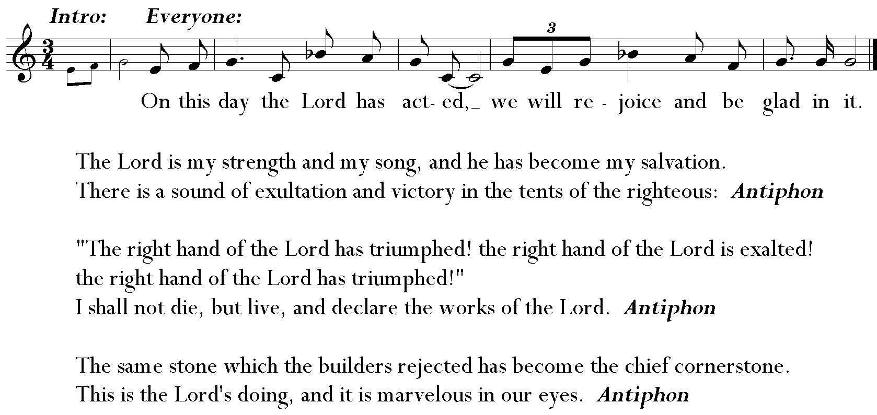**

**The Second Reading****1 Corinthians 15:1-11**

I would remind you, brothers and sisters, of the good news that I proclaimed to you, which you in turn received, in which also you stand, through which also you are being saved, if you hold firmly to the message that I proclaimed to you--unless you have come to believe in vain. For I handed on to you as of first importance what I in turn had received: that Christ died for our sins in accordance with the scriptures, and that he was buried, and that he was raised on the third day in accordance with the scriptures, and that he appeared to Cephas, then to the twelve. Then he appeared to more than five hundred brothers and sisters at one time, most of whom are still alive, though some have died. Then he appeared to James, then to all the apostles. Last of all, as to one untimely born, he appeared also to me. For I am the least of the apostles, unfit to be called an apostle, because I persecuted the church of God. But by the grace of God I am what I am, and his grace toward me has not been in vain. On the contrary, I worked harder than any of them--though it was not I, but the grace of God that is with me. Whether then it was I or they, so we proclaim and so you have come to believe.

*Reader* The Word of the Lord.

*People* ***Thanks be to God.***

**Alleluia Verse** A Repeating Alleluia Calvin Hampton

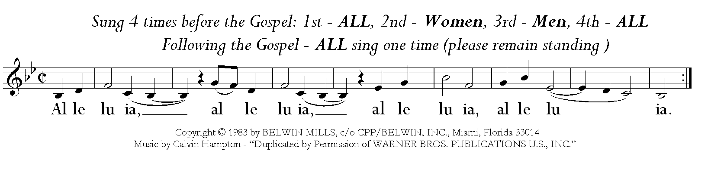

**The Gospel Mark 16:1-8**

*Celebrant* The Holy Gospel of our Lord Jesus Christ according to Mark.

*People*  ***Glory to you, Lord Christ.***

When the sabbath was over, Mary Magdalene, and Mary the mother of James, and Salome bought spices, so that they might go and anoint Jesus. And very early on the first day of the week, when the sun had risen, they went to the tomb. They had been saying to one another, “Who will roll away the stone for us from the entrance to the tomb?” When they looked up, they saw that the stone, which was very large, had already been rolled back. As they entered the tomb, they saw a young man, dressed in a white robe, sitting on the right side; and they were alarmed. But he said to them, “Do not be alarmed; you are looking for Jesus of Nazareth, who was crucified. He has been raised; he is not here. Look, there is the place they laid him. But go, tell his disciples and Peter that he is going ahead of you to Galilee; there you will see him, just as he told you.” So they went out and fled from the tomb, for terror and amazement had seized them; and they said nothing to anyone, for they were afraid.

*Celebrant* The Gospel of the Lord.

*People*  ***Praise to you, Lord Christ.***

**The Sermon** The Rev. Bill Garrison

**The Nicene Creed**

***We believe in one God, the Father, the Almighty,***

***Maker of Heaven and Earth, of all that is, seen and unseen.***

***We believe in one Lord, Jesus Christ, the only Son of God,***

***Eternally begotten of the Father, God from God, Light from Light,***

***True God from true God, begotten, not made, of one Being with the Father.******Through him all things were made.***

***For us and for our salvation he came down from Heaven:***

***By the power of the Holy Spirit he became incarnate from the Virgin Mary,***

***And was made man.***

***For our sake he was crucified under Pontius Pilate;***

***He suffered death and was buried.***

***On the third day he rose again in accordance with the Scriptures;***

***He ascended into Heaven and is seated at the right hand of the Father.***

***He will come again in glory to judge the living and the dead,***

***And his kingdom will have no end.***

***We believe in the Holy Spirit, the Lord, the giver of life,***

***Who proceeds from the Father and the Son.***

***With the Father and the Son he is worshiped and glorified.***

***He has spoken through the Prophets.***

***We believe in one holy catholic and apostolic Church.***

***We acknowledge one baptism for the forgiveness of sins.***

***We look for the resurrection of the dead,***

***And the life of the world to come. Amen.***

**The Prayers of the People Form III**

*The Reader and People pray responsively.*

Father, we pray for your holy Catholic Church:

**That we all may be one.**

Grant that every member of the Church may truly and humbly serve you:

**That your Name may be glorified by all people.**

We pray for all bishops, priests, and deacons:

**That they may be faithful ministers of your Word and Sacraments.**

We pray for all who govern and hold authority in the nations of the world:

**That there may be justice and peace on the Earth.**

Give us grace to do your will in all that we undertake:

**That our works may find favor in your sight.**

Have compassion on those who suffer from any grief or trouble:

**That they may be delivered from their distress.**

Give to the departed eternal rest:

**Let light perpetual shine upon them.**

We praise you for your saints who have entered into joy:

**May we also come to share in your heavenly kingdom.**

Let us pray for our own needs and those of others.

*Silence. The People may add their own petitions. The Celebrant adds a concluding Collect:*

*Celebrant* Almighty God, kindle, we pray, in every heart the true love of peace, and guide with your wisdom those who take counsel for the nations of the Earth, that in tranquility your dominion may increase until the Earth is filled with the knowledge of your love; through Jesus Christ our Lord, who lives and reigns with you, in the unity of the Holy Spirit, one God, now and forever.

*Celebrant & People* **Amen.**

*Celebrant* We pray to you for the forgiveness of sins.

*Silence.*

*Celebrant & People* **Have mercy upon us, most merciful Father; in your compassion forgive us our sins, known and unknown, things done and left undone; and so uphold us by your Spirit that we may live and serve you in newness of life, to the honor and glory of your Name; through Jesus Christ our Lord. Amen.**

*Celebrant* Almighty God have mercy on you, forgive you all your sins through our Lord Jesus Christ, strengthen you in all goodness, and by the power of the Holy Spirit keep you in eternal life.

*Celebrant & People* **Amen.**

**The Peace**

**Announcements**

**Offertory** Hallelujah from *Messiah* G. F. Handel

Hallelujah!... for the Lord God Omnipotent reigneth. Hallelujah!...

The kingdom of this world is become the Kingdom of our Lord, and of His Christ;…

and He shall reign for ever and ever. King of Kings, and Lord of Lords…Hallelujah!

The Parish Choir & Guests

**Presentation** – Doxology *Old 100th*

*Please join in singing wherever you are*

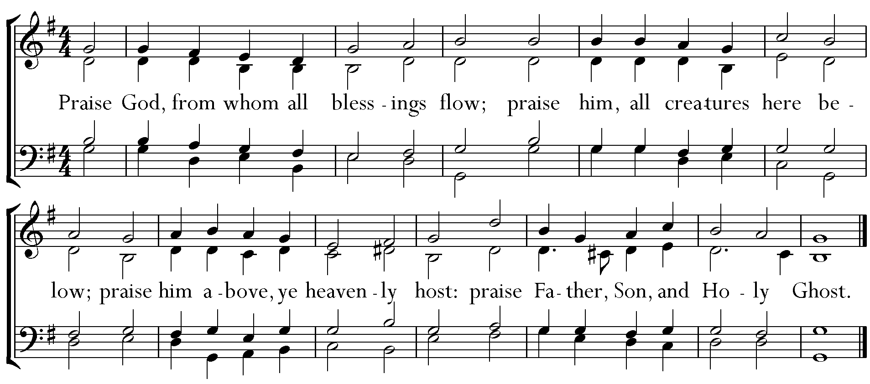

**The Great Thanksgiving Eucharistic Prayer “A”**

*Celebrant* The Lord be with you.

*People* **And also with you.**

*Celebrant* Lift up your hearts.

*People* **We lift them to the Lord.**

*Celebrant* Let us give thanks to the Lord our God.

*People* **It is right to give God thanks and praise.**

*Celebrant* It is right, and a good and joyful thing, always & everywhere to give thanks to you, Father Almighty, creator of Heaven and Earth.

*Here a proper preface is said.*

*Celebrant* Therefore we praise you, joining our voices with angels and archangels and with all the company of Heaven, who forever sing this hymn to proclaim the glory of your Name:

**Sanctus**



Hymnal 1982: #S-128: Music: William Mathias (1934-1992) Copyright: Copyright © 1976 Oxford University Press.

*Celebrant* Holy and gracious Father: In your infinite love you made us for yourself; and, when we had fallen into sin and become subject to evil and death, you, in your mercy, sent Jesus Christ, your only and eternal Son, to share our human nature, to live and die as one of us, to reconcile us to you, the God and Father of all.

He stretched out his arms upon the cross, and offered himself in obedience to your will, a perfect sacrifice for the whole world.

On the night he was handed over to suffering and death, our Lord Jesus Christ took bread; and when he had given thanks to you, he broke it, and gave it to his disciples, and said, “Take, eat: This is my Body, which is given for you. Do this for the remembrance of me.”

After supper he took the cup of wine; and when he had given thanks, he gave it to them, and said, “Drink this, all of you: This is my Blood of the new Covenant, which is shed for you and for many for the forgiveness of sins. Whenever you drink it, do this for the remembrance of me.”

Therefore we proclaim the mystery of faith.

*Celebrant & People* **Christ has died. Christ is risen. Christ will come again.**

*Celebrant* We celebrate the memorial of our redemption, O Father, in this sacrifice of praise and thanksgiving. Recalling his death, resurrection, and ascension, we offer you these gifts. Sanctify them by your Holy Spirit to be for your people the Body and Blood of your Son, the holy food and drink of new and unending life in him. Sanctify us also that we may faithfully receive this holy Sacrament, and serve you in unity, constancy, and peace; and at the last day bring us with all your saints into the joy of your eternal kingdom. All this we ask through your Son Jesus Christ.

By him, and with him, and in him, in the unity of the Holy Spirit all honor and glory is yours, Almighty Father, now and forever*.*

*Celebrant & People* **Amen.**

*Presider* And now, as our Savior Christ has taught us, we are bold to say

*People & Presider* **Our Father, who art in heaven, hallowed be thy Name, thy kingdom come, thy will be done, on earth as it is in heaven. Give us this day our daily bread. And forgive us our trespasses, as we forgive those who trespass against us. And lead us not into temptation but deliver us from evil. For thine is the kingdom, and the power, and the glory, forever and ever. Amen.**

**The Breaking of the Bread**

*The Celebrant breaks the consecrated bread; a period of silence is kept.*

*Presider* Alleluia. Christ our Passover is sacrificed for us;

*People* **Therefore let us keep the feast. Alleluia.**

*Presider* The Gifts of God for the People of God. The Holy Spirit makes the body and blood of our Savior Jesus Christ available in this moment to each of us within our souls as God recognizes our need during this time away from our home.

**Communion Hymn** At the Lamb’s high feast… *Salzburg*

**

Hymnal 1982: #174: Words: Latin, 1632; tr. Robert Campbell (1814-1868), alt. Music: *Salzburg*, melody Jakob Hintze (1622-1702); harm. Johann Sebastian Bach (1685-1750)

*Celebrant* Let us pray.

**Lord, make us instruments of your peace.   
Where there is hatred, let us sow love;   
where there is injury, pardon;**

**where there is discord, union;**

**where there is doubt, faith;**

**where there is despair, hope;**

**where there is darkness, light;**

**where there is sadness, joy. Grant that we may not so much seek to be consoled as to console;**

**to be understood as to understand;**

**to be loved as to love.**

**For it is in giving that we receive;**

**it is in pardoning that we are pardoned;**

**and it is in dying that we are born to eternal life. Amen.**

**Recessional Hymn** The strife is o’er… *Victory*

**

**

Hymnal 1982: #208: Words: Latin, 1695; tr. Francis Pott (1832-1909), alt. Music: *Victory*, Giovanni Pierluigi da Palestrina (1525-1594); adapt. and arr. William Henry Monk (1823-1889)

**The Blessing**

**The Dismissal**

*Celebrant* Go in peace to love and serve the Lord, doing the loving thing.

*People* ***Thanks be to God.***

**Postlude** Symphonie No. 5 – *Toccata* Charles-Marie Widor

**+++++++++++++++++++**

**French Horn Quartet**

Adrian Dunker, Daniel Kelley, Lisa McCormick and Preston Shepard

*The Bible texts of the Old Testament, Epistle and Gospel lessons are from the New Revised Standard Version Bible, copyright 1989 by the Division of Christian Education of the National Council of the Church of Christ in the USA, and used by permission. The Collects, Psalms and Canticles are from the Book of Common Prayer, 1979.*

Saint Matthias Episcopal Church  
7056 Washington Avenue, Whittier, CA  90602

Tel: (562) 698-9741 Fax: (562) 698-4347

Website: [www.stmatthiaswhittier.org](http://www.stmatthiaswhittier.com/) Email: office@stmatthiaswhittier.org